Multi hybrid Cloud Log management with LOG DNA
IBM Cloud+ logdna delivering solu to solve entrprs loggin n evt trackingChallenges to identify n fix issues faster

If I have this option, I expect to have those search boxes to be so smart. I don’t want to type the entire
word “tomato.” Instead,
I expect the search box to come up with suggestions, and I don’t want results and its recommendations
in random order.
I want the search to be smart and give me the most relevant results first. And also search should
not expect me to enter correct spelling for the product that I am looking for.
Here is an another example, I wanted to purchase a new laptop. To select the excellent model, I search for the
word “Best laptops.” on the amazon. As a result, I got to end up with more than 1000 laptop suggestions.
Which is not effective, right?
Only the Good keyword searching is often not enough;
you need some statistics on the results, so you can narrow them down to what the user is interested in.
I narrowed down my laptop search by selecting the ram size, the price range, and so on,
When I apply these filter on my search, I only had 10 or so laptops to choose from. While applying the
filter on top of lacks of the product,
performance is the primary concern. Because nobody wants to wait for 10 minutes.
The Relational Database works comparatively slow when it comes to massive data and fetching search results
through queries from the database.
Industries are nowadays looking for alternate ways where the data stored in such a way that the
retrieval is quick.
This can be achieved by adopting NoSQL rather than RDBMS for storing
the data.
Elasticsearch is one such NoSQL distributed database.
If you want to provide a search for your data, you’ll have to deal with the issues like returning relevant
search results.
returning statistics, and, more importantly, it should be very very quick.
But in reality, it’s not an easy task.
This is why the search engine’s like Elasticsearch come into play because they’re built to meet
precisely these challenges.
Elasticsearch is an open-source search engine built on top of Apache Lucene. It’s a full- text search
engine library. Lucene is the most advanced, high-performance, and fully featured search engine library.
Both, Lucene and elasticsearch are open source. But Lucene is just a library. To leverage its power,
we need to work in Java and to integrate Lucene directly with our application. And also, we require
more information to understand how it works.
I mean, Lucene is very complicated. Elasticsearch is also written in Java and uses Lucene internally for
all of its indexing and searching,
but it aims to make full-text search easy by hiding the complexities of Lucene behind a simple,
its uses, RESTful API.
This means every feature of Elasticsearch is exposed as a REST API like pushing data to cluster
we can call it as indexing, and deleting the data, updating the data, and searching data from the.
cluster.
You may be noticed, In a couple of places I have mentioned the word called “full-text search.”
Full-text search is a technique, which allows searching for documents not only by a title but also by content.
The full-text search goes through all the words in the document, showing more relevant information or
the exact information that was requested.
I mean, the elasticsearch engine examines all of the words in every stored document as it tries to match
search criteria.
For example, if you want to find articles that talk about “Elastic Search,” you might search using the
term “elastic.”
If any of the document matches the word “elastic” that will be retrieved. However, Elasticsearch is much more
than just Lucene, and it’s much more than “just” full-text search.
The main advantage of elasticsearch is It’s a distributed document store. Means, Once the document has
been stored in Elasticsearch, it can be retrieved from any node in the cluster.
And it is designed to hide the complexity that comes with being distributed. So elasticsearch can scale out
to hundreds (or even thousands) of servers and handle petabytes of data.
The good thing is, you no need any particular configuration for distributed systems, sharding, cluster discovery,
or dozens of other distributed concepts.
You can go with a single node living inside your laptop, If you were to run an elasticsearch on
a cluster containing 100 nodes,
everything would work exactly in the same way. Elasticsearch tries hard to hide the complexity of distributed
systems.
Say for example operations like Partitioning your documents into different containers and shard balancing
across the nodes and duplicating shards to prevent data loss in case of hardware failure and
more operations are happening automatically under the hood And another positive thing is performance.
While traditional DB’s struggling to handle Terabytes of data, elasticsearch handles it on the flow.
Comparatively, elasticsearch will take not even 5ms when relational databases like
SQL take 20 secs to get the data from substantial collection data set. That’s the power of elasticsearch.
But in the end, Elasticsearch is just a search engine, and you’ll never use it on its own.
Like any other data store,
you need a way to feed data into it,
and you probably need to provide an interface for the users searching that data. You can use elasticsearch
as a primary data source for your application, or You can add Elasticsearch to an existing
system.

ELK stack. E means, Elasticsearch

and this L represents logstash, and K represents kibana. Elasticsearch is the core. To work with
elasticsearch, we are going to use logstash and Kibana package. To work with elasticsearch,
We need to feed the data to elasticsearch, right?
The elastic stack provides the tool called logstash to pull the data from the source system and push
it into the elasticsearch.
Logstash is an open-source, server-side data processing pipeline that ingests data from a multitude
of sources simultaneously, transforms it, and then sends it to your favorite "stash.".
And what is Kibana?
Kibana is a visualizing tool to communicate with elastic search. It will provide a rich user interface
for the developer to play with the data available in the elastic cluster. Kibana is an open-source
analytics and visualization platform designed to work with Elasticsearch. You use Kibana to search,
View, and interact with data stored in Elasticsearch indices. You can easily perform
advanced data analysis and visualize your data in a variety of charts, tables, and maps.
Let's install these packages. For now, we will install elasticsearch and Kibana.
We will install a logstash later on this course. Go to the elasticsearch official website.
On top of this site, you see the the products menu,. If you hover the mouse cursor there, you can get this popup.
Click on the View all downloads link.
It will redirect you to downloads page. From here,
you can download all the packages related to elastic stack. You can see here, elasticsearch, kibana,
Beats, logstash, elastic cloud and JDBC client and lot more. But now, we are interested only on elasticsearch
and kibana.
Let's download those two packages. Let's download the elasticsearch package first.
I click this download link.
It redirects us to the elasticsearch downloading page.
This is the version we are going to work with this course. And see here,
there are lots of downloading options based on the environment you are using.
If you are using windows Machine, click this and download the package.
If you use Linux, download this. I am using Mac, So I will download macOS package.
Now, the elasticsearch package is downloading. See, it's a tar file.
We can extract this and directly start work on elasticsearch without any further installation.
See, it's downloaded.
I will navigate to this file location and just double click this file to extract.
If you are a windows user, you will get the elasticsearch library packaged as a zip file. You can unzip
and start work on the elasticsearch. Before we start to install this package,
we just visit the download page once for installation steps. First, download and unzip elasticsearch.
And then, go to the bin folder and execute the elasticsearch file.
If you are windows user, run elasticsearch.bat from bin folder. If the server started,
That's it.
You can directly start work with elasticsearch.
It's very simple right,
let's do that.
I'm navigating to the bin folder and open the terminal window from this location.
Let's hit ls command to see the files and folders available in this bin folder.
See here.
This is elasticsearch file, By running this file.
We can start elasticsearch server instance you if you order Windows user open this location on command
prompt.
Insert this bin folded.
You can see the file called elasticsearch, by running this file.
We can start elasticsearch server instance. let's run this ./elasticsearch, since I'm already
inside the bin folder I can directly execute this elasticsearch file.
That's it.
Just hit this comment.
If you order windows use it you can do an elasticsearch.bat. wait for some time to start.
elasticsearch instance. yes it's Started.
You can check the status in the web browser. open any browser and hit localhost:port number
9200 just hit this and see the response. the response indicates that elasticsearch instances
is up and running. let's install Kibana.
It's also simple as elasticsearch installation.
Let's go back to the kibana download page. Download the package based on the environment you are using.
I am download Mac version. Wait till download completes.
Once its downloaded
extract it.
Let's go to the installation page.
Download and unzip Kibana.
We are done this step. And next, Open config/kibana.yml in an editor and Set elasticsearch.hosts
to point at your Elasticsearch instance.
Let's go back to the extracted kibana package and go to the config folder. And open kibana.yml
file in any text editor.
I will just open this file and set the elasticsearch host. It means we have to configure kibana
to work with the elasticsearch, So we have to point kibana to the elasticsearch instance.
Now we are running the elastic search instance on our local machine, so the host will be localhost, and
port will be 9200.
It's already present in the file.
I will just uncomment this.
So If we start the kibana server, it will point to this elasticsearch instance, which is running on
this local machine.
If your elasticsearch server is running on any other server box,
you have to specify that location here.
Ok, fine, let's go back to the installation page. Kibana configuration is done.
Now are ready to start the kibana server. Run the kibana from the bin folder.
Let's go to the bin folder,
and I am opening the terminal window from this location and lets hit ls command to see the files
available in this folder.
See here.
this is kibana file run this.
./kibana hit this.
If you are windows user, open this location on command prompt. Inside this bin folder, you can see
the file called
kibana.bat; By running this file,
we can start kibana server instance.
Let's wait for some time to start
the kibana server.
See the status.
It's green, which means kibana is ready.
Let's go back to the browser and hit http://localhost:5601. 5601 is the port number used
by kibana.
See here. This is the kibana console.
So now, Kibana is ready to take our request.
Lets go to DEV Tools. This is the Kibana console that you can interact with elasticsearch.
In this console,
you can write the commands or queries in the left hand side.
If you hit this play icon, The query written here, will be send to the elasticsearch and the response we got
from the elasticsearch is displayed here.

----- KUBERNETES

https://github.com/wardviaene/advanced-kubernetes-course.git

Download Kubectl
- Download from: https://kubernetes.io/docs/tasks/tools/install-kubectl/

Logging with KUberneted----
Log Aggregation is done with modern tools
self hosted: ELK stack = elastic Search + LogStash + kibana
hosted srvcs like loggly.com, papaertrailapp.com >> can use to just send your logs to and they will do the processing for you.
use Fluentd with ElasticSearch with Kibana on Kubernetes to centralize all your logs and have it displayed in a UI.

Setting up a centralized logging using Fluentd, which will be used for log forwarding.
Clone : git clone https://github.com/wardviaene/advanced-kubernetes-course.git
..
cd advanced-kuber-course/logging/ , ls
all yamls in this.. es-service, es-statefulset.y, fluentd-es-configmap.y, fluent-es-ds.y, kibana-deployment.y , kibana-service.y, storage.y
Creating cluster ::
AWS_PROFILE=war kops ceate cluster –name=kubernetes.newtech.academy –state=s3://kops-state-b429b –zones=eu-west-1a –node-count=3 –node-size=t2.medium –master-size=t2.small –dns-zone=kubernetes.newtech.academy
execute and
agree with comand ::: LAUNCH the cluster
>> AWS_PROFILE=ward kops update cluster kubernetes.newtech.academy –yes –state=s3://kops-state-b429b
statefulset need storage so storage.yml
elasticSearch.yml > has authoriza , srvcaccnt ,
You will see that in the beginning of the file you will have a service account, a cluster role and a cluster
role binding which I’m not going to explain now, but this is for the authorization.
These objects I will be explaining in the authorization lecture. Right now I need to specify v1 beta1.
But if you have a more recent cluster than mine, then you can even remove the beta1.
But if this is the case, when you do Kubectl krate, then Kubernetes will give you an error if you have to specify
v1 instead of v1 beta.
If you have authorization on, if you have it enabled, then these lines will create the necessary roles
for this to work.
Let's have a look at the StatefulSet with the name ElasticSearch-logging and we are going to launch it
in the kube-system namespace.
You can use this as an add on.
I copied these files from the Kubernetes repository and they are meant to be used as an add on.
I'm just going to do kubectl add, but if you want
you can also use an s. Add-ons.
We add a few labels here, and then we have a specification. I’m going to have two replicas.
So we're going to have two instances of ElasticSearch.
And then you going to specify some labels.
And then we have the containers that we are going to specify. The image comes from an ElasticSearch image that has been
prepared by Kubernetes. It is hosted on the google-containers.
It has a name ElasticSearch logging.
We define resource limits.
It needs more CPU on initialization. That's why the request is lower than the limit.
And then we have the memory. We need two and a half. If you have a bigger cluster that has a lot of messaging,
a lot of logging than you might want to increase it as well.
We have two ports as we’re going to expose. 9200 and 9300. And then we have storage.
So every instance of ElasticSearch needs storage, durable storage, storage that when the pod is restarted
still needs to be there.
That's why we’re going to use es-storage.
And this is going to be mounted in /data. This es-storage is then defined at the bottom and then we
have a volume claim template here with the name es-storage.
I’m going to say that the access mode is, read write once, because it's going to be a aws-ebs volume. Storage
class name is standard, which is then defined in storage.yml.
So here I just opened storage.yml. Here we have then the name standard and this is aws-ebs volumes
of general purpose 2, which is a storage class and it needs to be launched in eu-west-1a.
So that's why we have this storage class here.
So we have this storage class here that we refer to and we say then just here, we need with the name es-storage
an ebs volume that is 8 gigabytes.
You can increase this if you need more.
So what's going to happen, because we have a StatefulSet with 2 replicas, what's going to happen
is there’s going to be 2 ebs volumes. One for each replica. A StatefulSet
is actually what I explained in the first Kubernetes course as a PetSet. A PetSet that has been renamed.
It stayed the same for the rest.
But now it's called a StatefulSet.
A StatefulSet you use, when you need static host names.
So ElasticSearch needs static host names because it's a cluster.
They need to be communicating with each other.
So you will always have a photo with the name ElasticSearch-logging dash 0 and then dash 1 and then dash
2, depending on how many pods you have in your StatefullSet.
So it's a predictable host.
And also you will have this volume attached to your replicas. We also have environment names we pass.
We pass the namespace and we pass a Java_Opt. Then we have a second container, the init container.
And this is just going to run one command and it's going to run a privileged command. It’s going to set a
kernel parameter, because ElasticSearch requires the vm max map count to be at least this number.
That's why you’re going to set this. If you already have this on a higher number then you can remove this.
So this needs to be here.
If it's a lower number then you need to set it to at least this number. If your operating system already
has a number that is higher on the whole system then you don't need it.
You could test this by logging into your instances and use sysctl and then as an argument adjust this
without setting it to a value and then you would see what this value is.
So this is an ElasticSearch, the StatefulSet and then we also have ElasticSearch service that we're going to use
to connect to port 9200 which is the API that we can connect to.
Kibana is going to use this 9200 to connect to ElasticSearch. Then we have the fluentd deployment.
Again we have authorization roles and then here we have a DaemonSet.
And DaemonSet means that on every physical note that we have this pod is going to run on just once. So you have
a DaemonSet.
If you have three notes then fluentd will run on every note exactly once. Again namespace Kube-system.
Then you have the spec template. I’m going to give it some labels again. There's also this annotation and it ensures that
fluentd does not get evicted if the node supports critical pod annotation based priority scheme.
I copied this from the official Kubernetes repository.
So make sure that it doesn't get evicted.
Then you have the container specification.
We're going to use this images on google-containers
again. We’re going to pass a few environment variables, again resource limits. We're going to have some
volume mounts, varlog, varlib docket containers, and a lib system directory and a config volume.
These are in the files right here in the volumes.
And this refers to the host path. So here this fluent container is going to mount the directory
of the host, var/lib/docker/containers in this pod,
and then this fluentd will be able to access some files from the whole system.
And this because it needs to access the log files so all the pods on that physical node will log
to a directory on the whole system.
The pod logs, the container logs will be in var/lib/docker/containers.
That's why fluentd needs access to it.
So it can part these logs and send it to ElasticSearch. It also needs access to a few system d libraries.
That's why we had this lib system directory here.
And we also have a config map. So here is the config volume that is then going to etc/fluent/config.d.
And there’s going to be another file that is in my report that contains a configuration. A fluentd configuration.
So then you can easily change the fluentd configuration.
One more thing to note that is very interesting, is the node selector.
Here we are saying that you can only run this pod on a node
that has a specific label.
So we are going to have to apply this label to every node that we want to run this pod on.
Otherwise it's not going to run right.
Let's have a look at the config map.
So here is the fluentd config.
There's an example here.
There's an explanation of how the logs are structured and then this is the configuration of fluentd.
If you're interested in this,
have a look at the fluentd website where this is all explained.
So we are rewriting some of the logs.
We have some format some filtering that we do.
And this then all goes to ElasticSearch.
So here at the end you see, type ElasticSearch, host ElasticSearch logging, port 9200.
So we have lots of input that we capture, and we all send it in
jsm format to ElasticSearch.
Then when the logs are in ElasticSearch, we also want to view them. We want to see them.
And that's why we have Kibana. We have a Kibana service and a Kibana deployment.
The Kibana deployment doesn't need any volumes.
It’s just a front end for ElasticSearch. It's a deployment. You're going to use d/kibana-logtrail:5.5.1.
It comes from my repository.
You can also use the official image rather than mine.
But this doesn't have a log trail in it. A log trail is a plug in to to show the logs in a nice
format. You can easily search your log files and you don't need to create your own dashboard in Kibana to
see your logs. Specify the ElasticSearch URL.
Port 9200 again.
And we also specify a few other settings where we say, we don't want xpack monitoring and xpack security.
The downside of this is because if you want if you enable this, you actually need to pay for it, so you
can use open source version.
But then there are add-on’s that you have to pay for.
These are add-on’s that are not free.
The downside is that there is no security on the endpoint.
There's no authentication that happens.
So you have to make sure that you filter on your IP address when we're going to set up this as a service,
or you have to implement your own authentication, so it is just a Web site basically that is hosting
on this port.
There's an export service.
So I will immediately show you the service.
Here is a service. I’m going to run this as a load balancer.
This Load Balancer will be open for the world.
So we have to make sure that you either filter on IP address or implement your own authentication on
this Load Balancer.
So this is then
the Load Balancer where we going to access the logs.
It will be an ebs Load Balancer on port 5 6 0 1 and then we want to access it and it's going to give
us the Kibana dashboard.

Fluentd deployment – > fluent.yml
fluentd-confgimap
env= ELASTICSEARCH_URL
kubectl get pods –namespace=kube-system
elastic search uses ebs volumes
kubectl get pv –namespace=kube-system
gives capacity accessmodes ,reclaim policy , status claim
Kibana – used for filtering log stashes .. cusomize volumes, run notes for centralizd logging. . with container name and logs msgs
AUTHENTICATION
x509 certs are used to auth urslf to kubernets api-server. These certs are issued wen cluster was setup for 1st time.
If minikube/kops this is done for you.
1. HTTP basic auth can be used. Convenient easier to use but less secure.
Only usrnm/pswd send to api-- less secure stil difficult to maintain.
How Enable: use a static pswd file on kubern master. Pass this path to file as argu to apiserver
--basic-auth-file=/path/to/staticfile.
This file format is . Password,user,uid,”group1,group2,grp3”

ElasticSearch which will be used for log indexing. Kibana for visualisations. Kibana is just a UI where you then
can visualize the logs. And optionally, you can use LogTrail which is an easy to use UI to show
the logs. LogTrail is a plugin for Kibana. This solution can be easily customized.
You can create custom dashboards to show what is important for you.
to add a user or change the password the API server needs to be restarted because then the API, server will read again this file. And only then the new user or assword will be recognized. Also another downside is that this passing of arguments might not be supported by the administrator tool that you're using. If you're using kops, kops doesn't support passing these arguments just yet. So we'll will have to make some minor changes to the boot processes to make sure that this argument is passed when the kube API is started. If you're using any other tool or you set up you cluster manually then you have to make sure that when the kubeAPI service starts that this argument is passed. So it requires some manual editing to the boot scripts.
2. AUTH using proxy ::
When using a proxy you can handle the authentication part yourself.
You can write your own authentication mechanism and provide the username and groups to the Kubernetes API once the user is authenticated. So this obviously involves some coding yourself. You will code the proxy yourself. And then you'll pass username and group to the Kubernetes API once the user is authenticated. This is a good solution if Kubernetes doesn't support the authentication method that you are looking for. The proxy setup will need the following steps: The proxy needs a client certificate signed by the certificate authority that is passed to the API server using the requestheader-client-ca-file. Basically you don't want anyone to act like a proxy. So your proxy also needs a certificate that it then can use to show to Kubernetes that is a trusted client that then will be handling the authentication. The roxy itself needs to handle the authentication (using a form, using basic authentication or another mechanism). So just imagine yourself you need to log in somehow using a form using some way before you even see the API or the UI of the API gateway. Once the user is authenticated, the proxy needs to forward the request to the Kubernetes API server and set an HTTP header with the login. So this proxy is some kind of server, you are logged in. Now this proxy knows your log in and then it needs to forward that request to the API server using a header to say 'OK this user John or this user Alice needs to log in, is already authenticated by the proxy and wants to use the API server.' This login HTTP header is determined by a flag passed to the API server. So when you start an API server instead of these basic outflag you can also pass flags for proxy. So this flag can be for instance requestheader-usename-headers=X-Remote-User. In this example, the proxy need to set the header X-Remote-User after authentication and that header that HTTP header that the proxy will pass to the API server will then identify what user wants to be logged in to the API server. The same with groups, you're going to have requestheader-group-headers=X-Remote-Group and that can be used as an argument to set the group header. Then you have another one X-Remote-Extra- allows you to set extra headers with extra information about the user. This is completely optional.It's just in case that you have more information about user that you want to send to the API server. This solution is very generic and you have tospend quite some time developing or setting up a proxy that will send these specific headers to the API server-side

3 Auth OpenID::
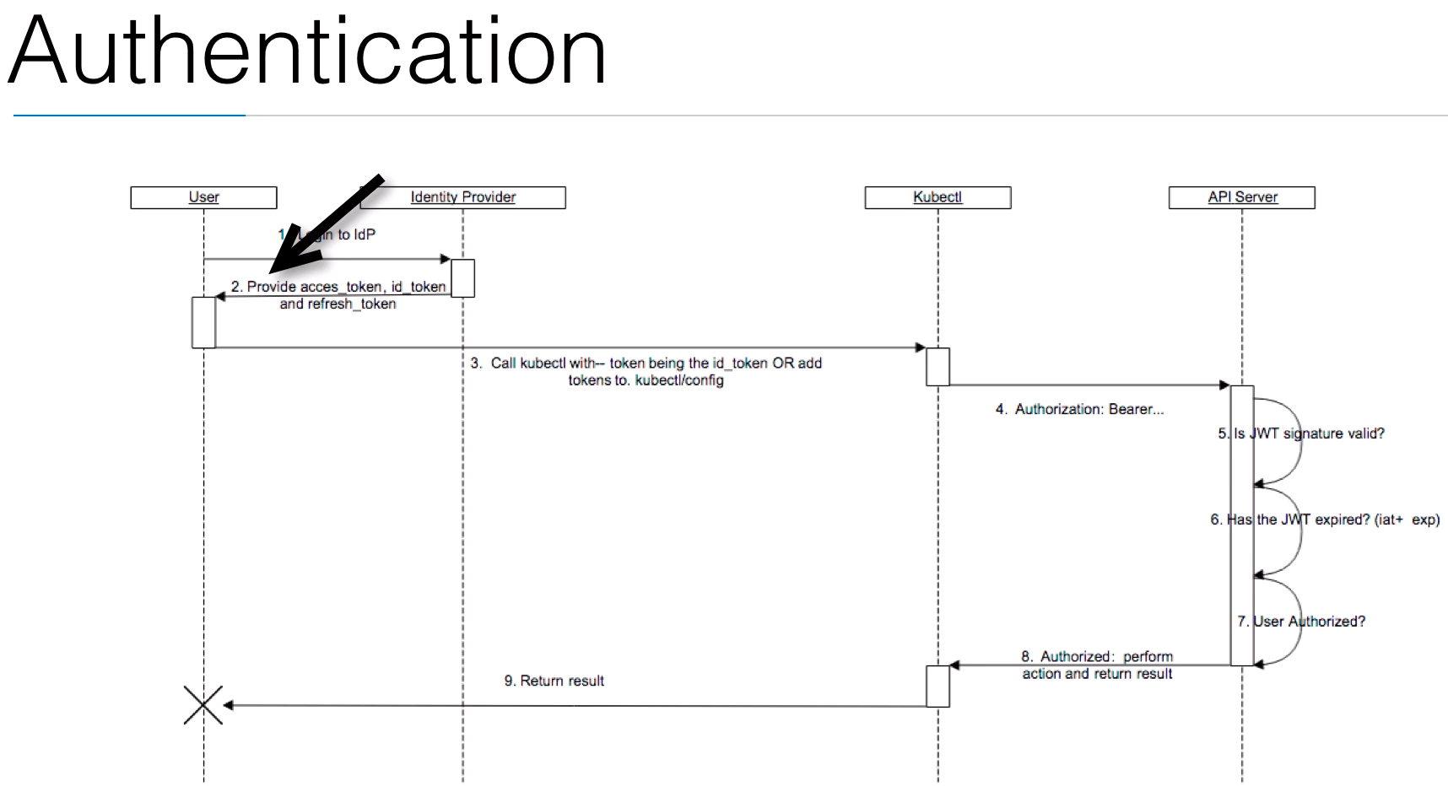

better alternative is to use openID connect tokens. OpenID Connect is built
on top of OAuth2.
It allows you to securely authenticate and then receive an ID token. This ID token can be verified whether
it really originated from the authentication server because it's signed using HMAC SHA8256 or RSA.
So either a signing algorithm or an encryption algorithm. This is important because the authentication server
is not Kubernetes.
This can be a third party. This can be something that you set up yourself.
This is the server that will then give you this token and then later on Kubernetes can then validate whether the
signature is real, whether it really came from the authentication server and it doesn't need to go back
to this authentication for every single request that you do to the API server.
So it's a really robust way of dealing with authentication.
This ID token is a JSON web token. Also called JWT. A JWT contains known fields like username
and optionally groups.
So you get this token from the authentication server, it's signed
so Kubernetes later on can verify that it's real, and this token then contains your user information,
like a username and optionally groups. Once this token is obtained.
It can be used as a credential to authenticate to the API server.
You can pass --token= when executing kubectl commands or you can put it
in your configuration file.
Kubectl can also automatically renew your token_ID when it expires.
So your token_ID has an expiration date and when it expires
Kubectl has a mechanism to go to the authentication server and ask for renewal of this token_ID.
Although this doesn't work with all identity providers, it really depends on what software you are using but
it’s way of renewing is compatible. Using this token
you can also authenticate to the Kubernetes UI.
You can authenticate to the web UI which is actually the API server or you can just use kubectl. To make
this easier because this is a web front end, I create a reverse proxy that can authenticate you using openID
connect and then pass your token to the UI. Because this token needs to be set as an HTTP header
so it's much easier if you have an authentication server in between that will redirect your connections
and will just inject this token for you.
This is the flow that we are going to follow.
So you are the user and first you're going to log in to this identity provider.
This identity provider is going to provide you with an access token, ID token
and refresh token.
It really depends on the implementation of the identity provider whether you get all these three things
or just an ID token.
The one I am going to use in the demo doesn't give you automatically a refresh token. If your ID token is invalid
you just have to renew it yourself.
Then on number three, you can call kubectl with --token being the ID token.
Or you can add this ID token to the kubectl config file. Then kubectl is going to do an HTTP
request to the API server and is going to add the HTTP header authorization there and then a token. Then
the API server gets this token ID, this JWT and it's going to verify whether the signature is
valid.
To do that it previously connected to the identity provider to get a certificate to use that certificate
to then validate your signature. The API server caches this
so it doesn't need to go back to the identity provider
every time you want to execute something. Now this can be done offline because we are using the encryption
algorithms or the hashing algorithms.
So if the JWT signature is valid, if it really comes from the other provider, then the API server is going
to check is it still valid.
Is it not expired.
Because that information is included in this token. If it's valid, then the authentication is succeeded.
Number 7:
I'm going to explain in another lecture.
Number 7 is, is the user authorized to do this.
First you have authentication using the token.
Then you have authorization. Is the user authorized to access these resources or to change these resources.
If this is the case then the action is performed and Kubernetes will return the result and then the user
will see the result.

Auth with authO
AuthO acocunt identity Provider is free for sometime.
Create authO client for kubernts
setup cluster with oidc (OpenIdconnect) using kops edit
deploy auth srver (for UI proxy + to hand out beares tokens)
change var to match authO
crete DNS record for auth srvr
try loggin into UI through aut srvr
1. https://autho.com = Identityprovider as a srvc
client – create . Name = Kub
give domain
cleintiD, secret is there
allowed callbackurls : some http://hostname/callback
jwt expriation time in hours
create cluster with domain n all info on this page.
Login to git repo.. < > authnetiation dir..
cat readme.rd.
How to create UI. N kub api server.
Login to cluster, edit for openidconnect . Give the detials.. run and once up.

test nodes are up ..
$>> kubectl get nodes
Create UI. : kubectl create f https://raw.githubusercontent.come/kubernetes/kops/master/addons/kubernetesdashboard/v1.6.3.yaml
ls > cat auth0-secrets.yaml

vim autho-deplyment.yaml
env name – clientid, auth—connec add userid/paswd
echo -n “%copy secret%” |base64 >> excryptedtcxt
echo “excryptedtcxt%” | base64 –decode >>> get back %copy secret%
put the secret enc in authoclient secret.
DB connec – can be created in Autho site.
Once done, add this to kubernet – enable db conn
can create users here in Autho site. as well.
Create the cluster with all the authO updates ..
/authenitcation>> kubectl create -f .
deply create, secret creted, srvc created
kubectl get pods
code is in kubernetes-auth-server.
Find code for auth on AuthO under clients > for al llanguages
after login can check logs in Auth0 → logs
AUTHORIZATION
After authentication authorization controls what the user can do.
Where does the user have access to. The exit controls are implemented on an API level.
So on the kube API server. When an API request comes in for example when you enter kubectl get nodes
it will be checked to see whether you have access to execute these commands.
There are multiple authorization modules available in Kubernetes. You have the node authorization.
It's a special purpose authorization mode.
That authorizes API requests made by kubelets.
So this is internally.
that the nodes can have access to what they need to execute.
Then you have ABAC which is an attribute based access control, access rights are controlled by policies
that combine attributes.
For example use Alice can do anything in the namespace marketing. ABAC does not allow very granular permission
control.
I'm not going to show you a demo of a ABAC.
That's why I'm showing you a RBAC demo.
So that brings us to our RBAC which is the role based access control and the role based actually control in
Kubernetes allows you to have really granular permissions.
It regulates access using roles. It allows admins to dynamically configure permission policies. So we
create a permission policy and then you can add user or groups to it. It Beta since Kubernetes 1.6.
But I expect it soon to be stable.
And then you have another type, you have the web hook type. It sends authorization requests to an external
rest interface.
The Web Hook is an interesting option if you want to write your own authorization server.
So if you don't want to use RBAC but you want to use your own authorization software then you can implement
an authorization server and then you can parse the incoming payload which is json
and reply with access granted or access denied. To enable authorization mode
You need to pass authorization mode equals something to the API server at startup.
So this is the KUPE API server that you have to pass this to. For example to enable RBAC you pass
dash dash authorization mode equals RBAC. When using kops which I'll be using during my demo you can create
a cluster with the flag
dash dash authorization. By default by not specifying the flag you are allowing
everything. It is the same as specifying the flag authorization
equals always allow.
So then you don't really have authorization, any user that is able to log in, can do everything.
This might change in the future.
I think when RBAC becomes stable and it's not beta anymore maybe the tools like kops will use
RBAC by default. When specifying dash dash authorization.
The cluster will be created using our RBAC.
And that's what we do in a demo.
If you're cluster is already set up with kops.
You can use also kops edit cluster and change these lines.
You can change the kube API server and you can change the authorization mode. If you're using minikube you can
add a parameter when starting Minikube you can start minikube with Minikube start dash dash extra
config equals API server dot authorization dot mode RBAC.
If you are using another tool to set up the cluster you will have to refer to documentation of that
tool because every tool to set up cluster will have a different way of implementing this option.
If you set up your cluster manually you have to take a look at the boot scripts.
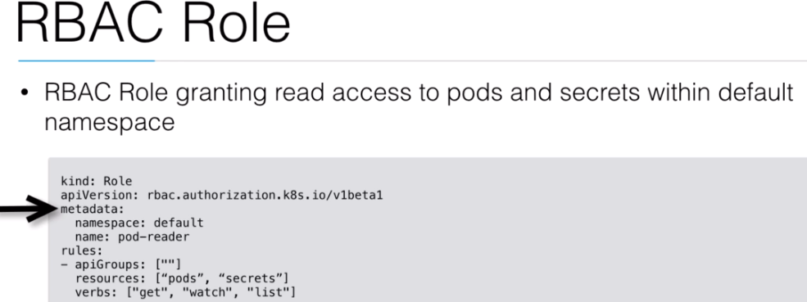
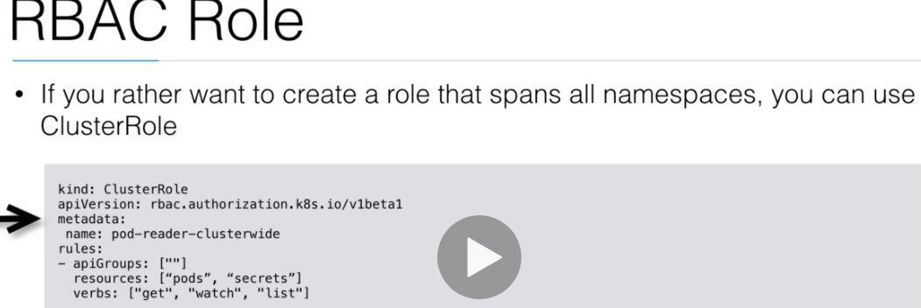
So the bootscript like systemd the will start of the kube API server and that's the place where you
will have to edit this argument to have authorizations that to RBAC.

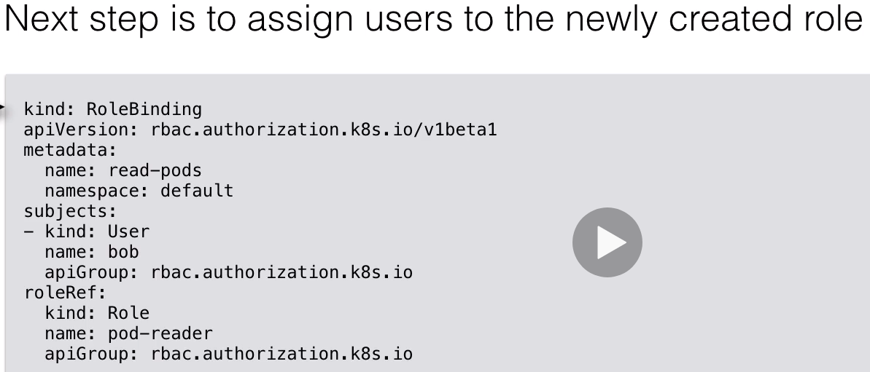

. You can add RBAC resources with kubectl to

grant permissions.
So basically you first described them in a yaml format and then apply them to the cluster like you
do with all the other resources.
You first define a role and then you assign users or groups to that rule.
You can create two types of roles you can create roles limited to a namespace or you can create roles
where access applies to all name spaces.
So basically namespace specific or cluster wide. The different kinds of resources that I'm going to show
you
next are a role which is single namespace and a cluster role which is a cluster wide role and a role
binding where
we going to assign users or groups to a role. Role binding
Is single namespace and cluster role binding is cluster wide.
So here we have the first example we use an RBAC role granting read access to pods and secrets
within the default namespace. Its of kind
Roll. The API version is RBAC authorization kubernetes.io/v1beta1
So it's still in beta.
So this API version might change in the future.
What it means is that you might have to remove the beta1 at the end at some point.
We add metadata, you going to say the namespace is defaults.
We are granting permissions to the default namespace we give it a name. This role is named a pod reader.
And then we're going to specify the rules.
If you specify API group equals nothing then we are referring to the core API group.
So the core API is going to be where the pods are defined.
You have other API groups like for instance the deployments that you have to define API group deployments.
I have an example later on that shows that.
So here we have pods and secrets.
These are the resources that we want to control and then we are going to say verbs, get, watch and list.
So where we get this role, can get watch and list the pods and the secrets.
The next step is to assign a user to this role.
But first let me show you another example.
Let me show you the same role but then cluster wide.
So here if you rather want to create a role that spans all names spaces you can use cluster role.
So the only thing that changed here is that we have kind cluster role and in metadata we don't have
namespace.
So this will be a pod reader cluster wide not limited to one namespace.
It will be able to get the pods and the secrets in all namespaces and then the next step is to assign
users to the newly created role.
So here we have a role binding. Kind: role binding, metadata, give it a name again, you specify namespace default
and then you have the subjects, here we have one user which has a name Bob we have to specify the API
group which is still RBAC authorization kubernetes.io
And then we going to specify the role reference, we’re going to say this user needs to be linked to this
role.
We going to say kind is role, I want to link this user to a role and the role name is pod reader.
So now this user Bob is linked to the first role we created this role is specific to the default namespace
this user bob will only be able to get a pulse in the default namespace not in any namespace.
If you need to assign a user to a cluster wide role you need to use cluster role binding.
So here we have cluster role binding instead of role binding.
And it looks exactly the same but we don't specify a namespace.
This binding by its user Alice to the pod reader cluster wide.
And then this user Alice will be able to get pods on all namespaces.

Enabling RBAC:
cd authorixation / cat rEADME.md
>> AWS_PROFILE=ward kops create cluster –name=kubernetes.newtech.academy –state=s3://kops-state-b429b –zones=eu-west-1a –node-size=t2.small –master-size=t2.small –dns-szone=kubernts.newtcg.academy –authorization RBAC
update cluster.
> kops edit cluster kuber.newtch.acadmey –state=s3://kops-state-b429b –yes
In this demo, this authorization demo I'm going to show you what a enable RBAC and I'm going

to show you how to use auth0 to add groups to our token so we can use those groups in RBAC.
So here I am again in my git repository in the advanced kubernetes course and I have a folder authorization.
In this authorization folder.
I have some code listed this is the code that we have to add to our Kube API server
again if you haven't done this already where we have to enable authentication there is one difference
here.
The OIDC username claim.
If you want to use the e-mail address you have to specify name because in ID token the field name refers
to the e-mail address.
You can still use sup but that is a more unique user name than just the email address something provided
by our auth0.
And then we have the OIDC groups claim and these groups claim refers to a field that will have this
URL claims groups.
This prefix this namespace you can change this because later on in this demo I'm going to show you where
you are creating this namespace for groups.
So let's first create the kops cluster so I'm going to do again.
Kops create cluster.
I'm going to have 2 nodes. t2 small notes, and then I'm going to add authorization RBAC.
So it's going to enable the authorization and then I’m going to do kops edit cluster before I'm going
to bring it up because I need to because I need to add the authentication and I’m just going to tell
kops that my AWS profile
is ward because that's the credential I have configured in amazon.
So you see here authorization RBAC and just above that
I'm going to say kube API server.
My issuer is going to be newtech academy. My client ID
I need to copy paste again.
So there's my kubernetes client.
Newtech Academy eu auth0 dot com is my domain.
I need to copy paste my client id and then the username claim is going to be name and the groups claim is going
to be this.
That should be OK.
And then I'm going to update the cluster, say dash dash yes this is going to bring up the cluster with authentication
and authorization enabled then I still need to configure auth0 because I need to enable an extension
to have the groups in my token.
So the cluster is starting to be ready in a few minutes.
So let's then create the configuration necessary in auth0.
So this is auth0.
And here we have extension's And here you should find the authorization extension.
I already have it enabled but you can just click on this and then click on install.
Then once the extension is installed you can click on it to configure it and you have users groups
roles and permissions.
And this is the user that I created earlier.
On the user's page right here. So I’m going to create a new group and I want to call it developers and then
I'm going to assign a new user to it.
I'm going to add a number and I only have one user so I'm going to use this one.
So now we have one group with one user, still need some configuration.
We click right here on the right top and you click on configuration.
You have to make sure that this group's token contents is added. So you enable groups then you
click publish rule and it’s going to add a rule to add the groups.
And then we still need to add a rule because it all needs to be OIDC compliant.
We're going to go to rules.
And we now have 1 auth0 authorization extension rule that you're going to create a new rule. Go to an empty rule.
Going to call this rule add group to token, going to remove everything, then we go back to our read me
in the read me
There's a rule to add the group with a namespace to the ID token.
So to make it OIDC compliant you always need a namespace.
So this is going to be our namespace and then we go going to say permissions equals to user permissions
groups equal to user groups and roles
equals to user roles.
So then we're going to have groups roles and permissions from this extension in our token.
So we add this rule you can change this but this needs to be exactly the same as you configured in the
cluster menu that kops added and then we’re going to save this.
This is our authentication server.
So this is the service that I showed you in authentication lab.
So if you don't have this running you need to bring it up again.
So let's bring it up again by going to
authentication, let's have a look at whether the cluster is up, the cluster is up and then lets do kubectl create
of this auth0 deployment secrets and service. Then make sure again that you login to AWS and you link
the DNS record to the load balancer that is is created and then you should be able to go to the URL.
Well I also sometimes do is you can have multiple authentication servers, if you need one to test you
can also deploy one locally and that is what I did.
I deployed one locally so you can just start a Python script locally as well if you want instead of
deploying it on your cluster and then that shouldn't make a difference because it's still auth0
giving you these tokens. So I'm going to log in with my username and then I see here that I am now in the
group developers.
So I am in the group of developers this is my name is my user name here.
This is the sub which is provided by auth0 which is unique, it’s like my ID.
So I'm going to say to kabernetes please make me a role and add the group developers to this role.
So when I go back to authorization and here I have a role dot yml. This is of kind role.
It's called Pod reader but we can also execute something with it namespace is default and then we’re going
to say we have a role binding.
And these are the rules.
We have rules that we can create pods and create deployments. You have a roll binding where we're going to
say we have a group developer and we want to have the group developer attached to the pod reader. Pod reader
is not the greatest name.
It should just be pod writer or developer or something.
But you can change this.
You can change this into anything you want.
Well what I'm going to do now is going to create a new account just on this local machine just to have
two accounts to log in with my certificate on one side and to use the auth0 user on the other side.
So let me use two tabs here and then I’m going to do sudo
add user kubernetes test. Can fill this out.
Now I have a new user
I’m going to sudo su into this user.
And then I need to copy the kubectl config.
Otherwise I will not be able to contact even the server. I'm not going to copy the certificate itself but
I need the CA of the cluster.
So I'm just going to copy this, just the cluster information but not the certificates.
We want to create a directory kube, create kube config.
So let me now do kubectl get nodes.
And it says enter user name because I don't have any credentials.
That's why I first need to configure again this authentication
Helper scripts.
So I'm going to go to my repository
is my authentication server and going to make an alias just like I showed you in the previous lecture
to make an alias in this case I stored my my variables in this file here.
So I don't have to pass them as environment variables.
You can also use this .env file. It’s the same but you rather use the example.
I explain to you in the previous authentication lecture.
So let's try kubectl get nodes now again.
And then we have to put on Login. This is now my script asking for the login, newtech academy and it gives us error
from server.
So our authentication worked but now we have the user ward at newtech academy can not list the nodes at
the cluster scope.
So we don't have any access now to do this. Lets try get pods, the same, we get the forbidden, so kubernetes API
server now that RBAC is enabled is saying we cannot do this.
Let's go back to our normal user. So here
this user is using certificates.
So the user can still list the pods.
Let's kubectl
create minus F role dot yml and he's going to create the role pod reader and then role binding
is going to bind it with developer group
and then just realized that I made a mistake because I entered developer developers in auth0.
So I'm going to just change this into developers
and then I'm willing to do the create and then I go here kubectl get pods and then I can see the
pods.
I'll try kubectl get nodes and still get an error.
I try kubectl get pods
Namespace equals kube system.
And I also get an error.
So the only access that I have now with this user in this group developers is the access described right
here in rules and that is I can get the pods and the deployments from the default namespace I can
create new pots I can create new deployments I can even delete them but I can only do this in a default
namespace and I cannot for instance get the nodes.
So this is really good if you just want to have users developers that cannot change any admin things
on the server but they need to be able to create deployments or to update their deployments.
So let's try the hello world.
So let's do kubectl run which will create a deployment. The image is a google container, is an
echo server and then we have deployment created.
We can do kubectl get pods or just get pods and we see here that this container here is creating.
this one years crashing because I didn't configure it properly.
I also have an authentication server running locally because I didn't enter all the correct information.
I didn't give it the secret so that's why this one is crashing.
I can still get it a token because I have a local server configured one outside the kubernetes. You're
authentication
server doesn't really need to be inside kubernetes because it can be outside kubernetes because it
just needs to connect to auth0, get a token.
Once you have a token, you log into kubernetes. kubernetes checks the token with auth0.
So it doesn't really matter really where this authentication server is running. This kubernetes
authentication server is not created by me.
I can even still delete this one.
I can still say kubernetes delete pods kubernetes authentication server.
So I didn't even created this.
This was my user with the certificate that created it but because I now have these access right I can
delete anything here on this
namespace but if I want to do something in another namespace like kube system it will still be forbidden.
If I then do a kubectl delete with my admin user that is using certificates then this role is gone.
I want to do kubectl get pods.
I immediately get an error from the server.
So this is really how RBAC authorization system works in kubernetes, it’s still in beta but it will
be stable very soon I think.
And then this will be the way that you can use roles and that you can protect your cluster and that
you can use really granular controls for any group in your system.
I showed you how to do this with auth0, but you can really use any identity provider as long as this
identity providers support groups.
If it doesn't support groups it supports probably users and then you can also use, then you can also use here subject
kind user instead of group.
That's also possible.
So that was it for these demo.
You see authentication and authorization is very closely coupled together.
You have to first set up authentication then authorization and then they work nicely together.
Good luck trying this out on your own.
I hope you don't struggle too much when you try this out on your own.
If you have any questions use the Q&A to ask me anything that doesn't work.
Make sure that you also give me some information like copy paste some output or some errors so that
I can help you debugging your problem.

PACKAGING HELM
Let's talk about packaging with Helm. Helm is the package manager for Kubernetes. Helm helps you

to manage Kubernetes applications.
It is maintained by the CNCF. The cloud native computing foundation.Together with Kubernetes, fluentd, linkerd and others. So this cloud native foundation is a foundation
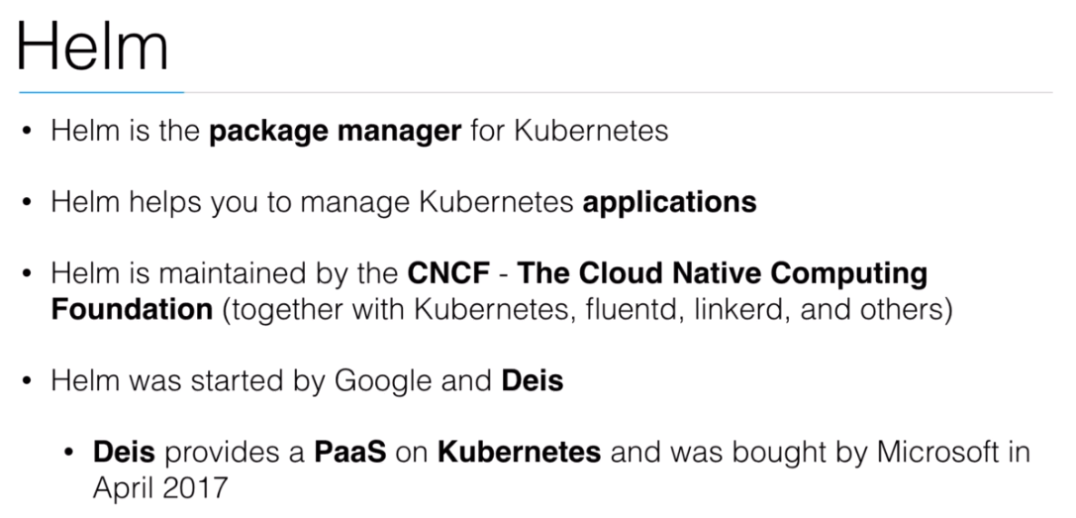
that maintains all these pieces of software.Kubernetes is the biggest piece of software in its foundation
with other tools like fluentd which we already covered and other tools that are often used in distributed
systems in Kubernetes are also maintained by this foundation.
End bundles, cloud native computing tools together. Helm was started by Google and Deis. Deis provides
a platform of service on Kubernetes and was recently bought by Microsoft in April 2017.
I also have a course of briefly covering Deis on Kubernetes.
It's called scaling applications on premise and on the cloud where I cover a little bit of Deis. Deis
can help you if you just have applications that you want to run on something like Kubernetes but you
don't want to be exposed to all the details like pods and deployments.
You just have a good repository with no jazz, ruby or PHP application and you just want to run that. A little
bit like Heroku which Deis is inspired on.
If you're interested in that then you can have a look at this package.
It is something that is built on top of Kubernetes. So Deis and Google started Helm the package manager
because they needed it to install packages on Kubernetes.
But now we can also use Helm separately without ties to install packages on Kubernetes. Helm
uses a packaging format called charts.
A chart is a collection of files that describe a set of Kubernetes resources.
A single chart can deploy an app or a database.
It can have dependencies for instance to install the Wordpress chart.
You need a mysql chart because Wordpress the blogging engine needs a database.
Mysql.
So you can see if you want to install WordPress.
Then you also need mysql.
Just like a normal package manager but for Kubernetes. Charts
use templates that are typically developed by a package maintainer.
They will generate yaml files that Kubernetes understands.
You can think of templates as dynamic YAML files which can contain logic and variables.
This is an example of a template within a chart.
Here we have a config file resource in a yaml file just like it would normally define it for Kubernetes.
But you can see you have variables here and those variables still need to be filled out.
So for instance the favorite drink value can then be overridden by the user
when running helm install. so a user will run Helm install and then specify a value for a barometer
so that this value can be filled out in the yaml file. overwriting values can be useful to make sure the
app is configured in a way you want.
So here is an example of the helm mysql container and if you want to launch my sequel you want maybe
to specify some of these parameters.
So these are the parameters that you can specify for this Helm
mysql package and depending what kind of storage you want what kind of persistent storage you want, you
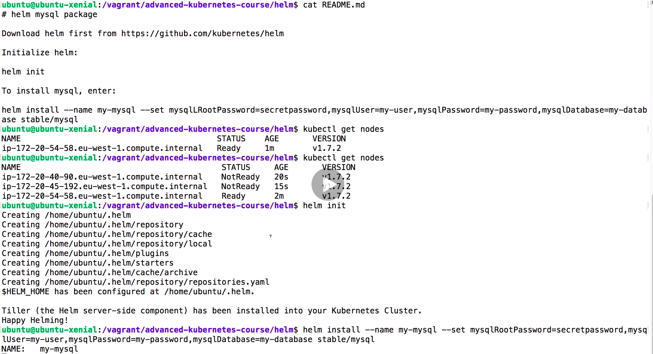
can specify different variables.So here are the bottom three.
Persistence enabled.
Create a volume to store the data.
True is a default within.
What size do you want to have it.
Maybe you want it more than the default and maybe you also want to define the storage class to define
a type of the persistent volume claim.
Then you also have some specific software barometers like you have here on the top 4. The mysql root password,
the user, password and a database.
So if you're going to launch something like Wordpress then you need a user password and database.
You might then set these variables here.
This mysql helm package will come up on your cluster with the username and password and database that you
have chosen.
And you can reuse those variables within your Wordpress to connect to the database.

INSTALLING MYSQL with HELM

